**Embed License File into MSI**

Modify MSI to place a license key file in the correct directory automatically.

**About the Project:**

The project focuses on modifying an MSI installer to embed a license file (license.key) into the appropriate installation directory. This ensures that when the application is installed, the license file is automatically placed in the specified folder without manual user intervention.

*Before proceeding with this task, it is essential to install a few critical tools and dependencies to ensure a smooth and successful setup.*

**Requirements Before Starting:**

**Project Requirements:**

1. **Orca Editor (part of Windows SDK)**
2. **WiX Toolset (Wix314.exe)**
3. **Dummy MSI file (DummyProduct.msi)**
4. **Dummy License Key file (license.key)**
5. **Folder Structure:  
   Example: C:\Users\sachi\OneDrive\Documents\Project2**
6. **File Size in Bytes (for license.key)**
7. **Developer Command Prompt**
8. **Basic text editor (Notepad)**

* **Tasks Performed:**

**Performed on a local Windows machine with tools like Orca and WiX Toolset:**

* **Installed Orca via Windows SDK**
* **Installed WiX Toolset**
* **Created and configured .wxs file**
* **Built updated MSI via command line**
* **Embedded license.key using Orca**
* **Tested final MSI output**

**Step 1: Orca Installation steps**:

1. Click on download the installer

Open <https://developer.microsoft.com/en-us/windows/downloads/windows-sdk/> and click **Download the installer** to download **winsdksetup.exe**

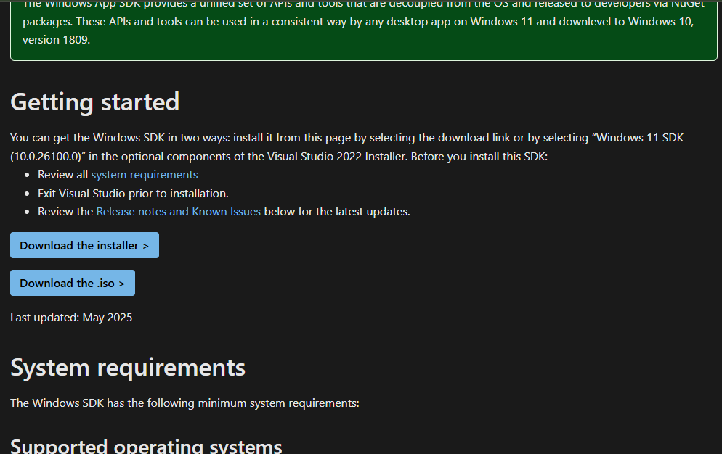

1. Select the second **radio button** and browse path then download………… then NEXT

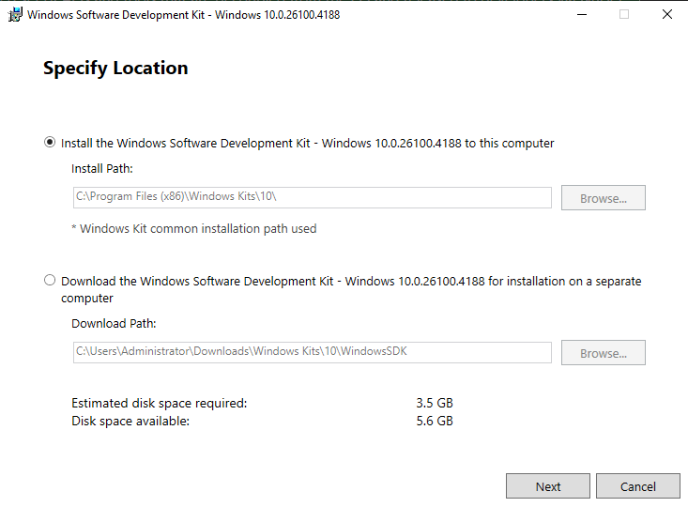

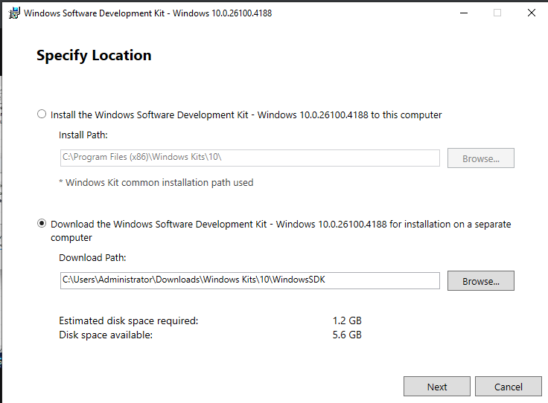

Click on **YES**

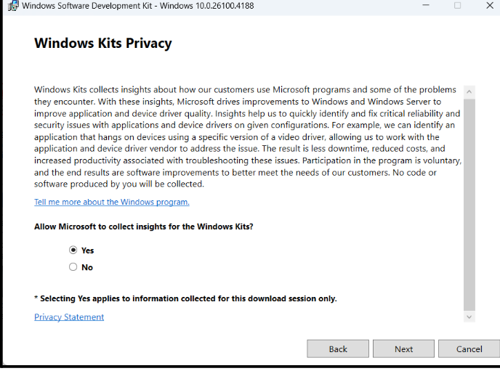

1. Select all the options and click on next->

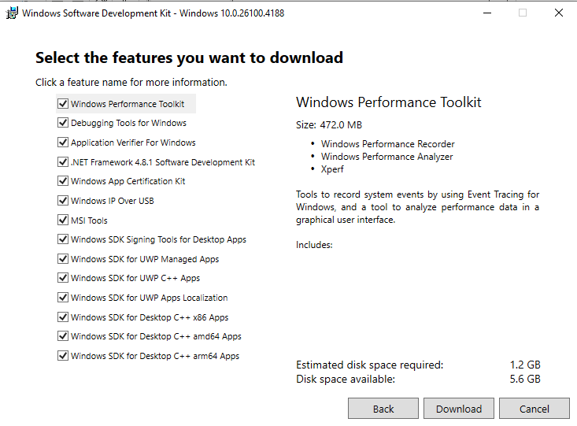



1. Double click on Orca-x86_en.msi ->Navigate to this path

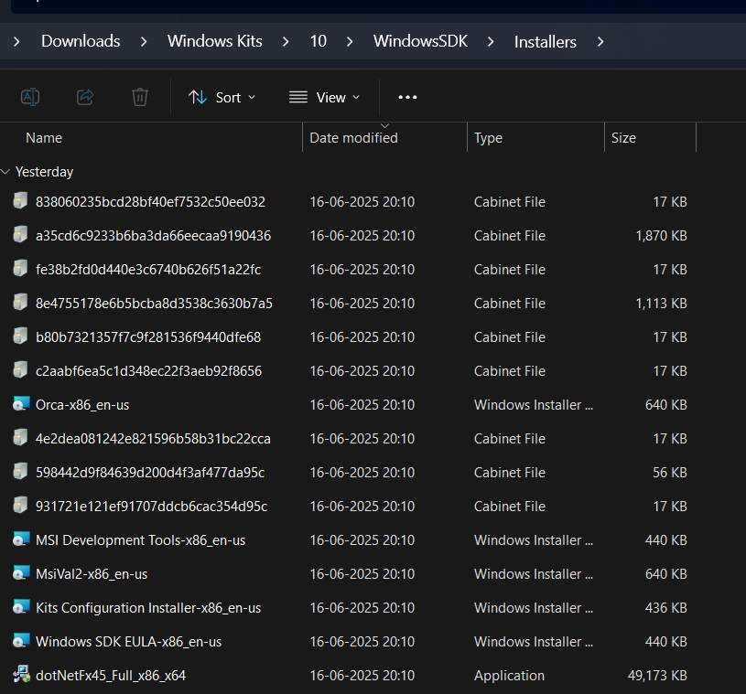



1. 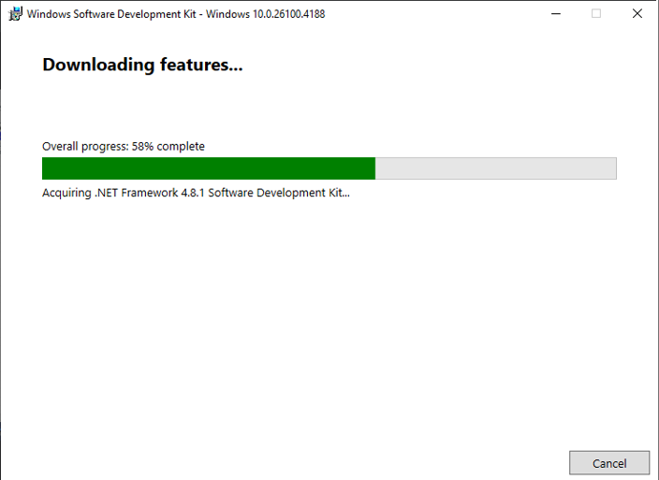Downloading---------------

**Step 2: wixtoolset Installation steps**:

* 1. Download **wix314.exe** from <https://github.com/wixtoolset/wix3/releases>

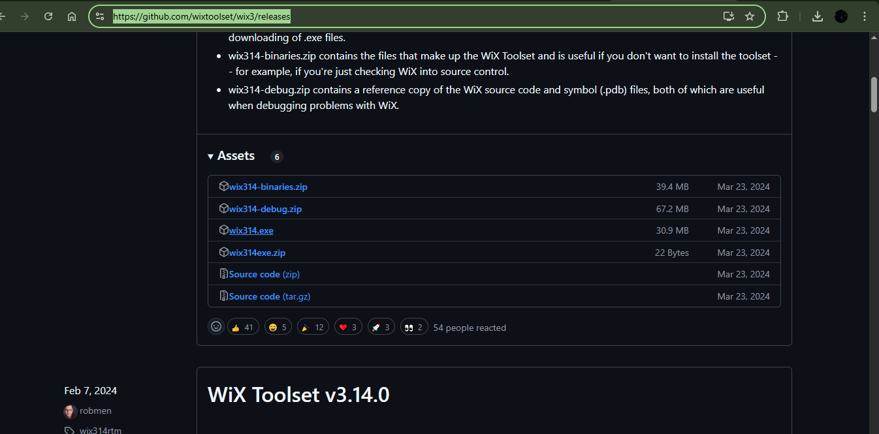click on 3rd option wix314.exe



* 1. Click on install in win314.exe file

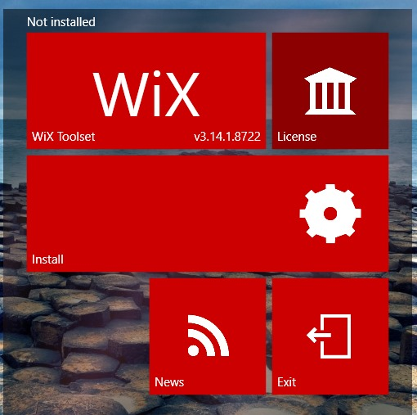

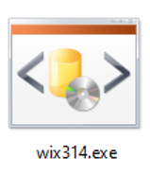

**Step 3:** Extract the dummy.msi file in the Project2 folder you can see three file here we can’t see license file here till now

-> C:\Users\sachi\OneDrive\Documents\Project2

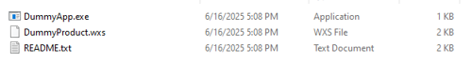

-> Go to DummyProduct.wxs modify the file

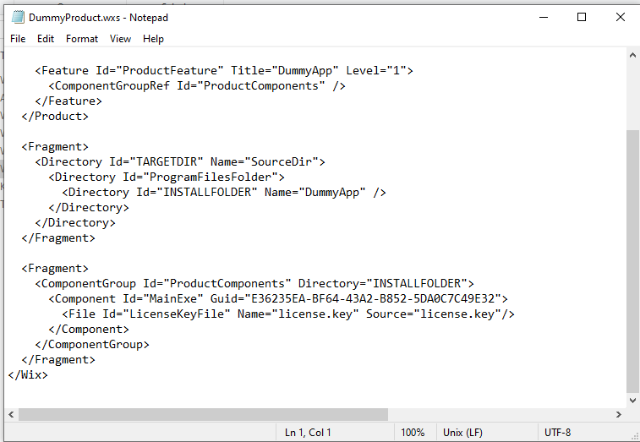

**Step 4**: Open Notepad and create an dummy license key file and save it in the same directory Project2

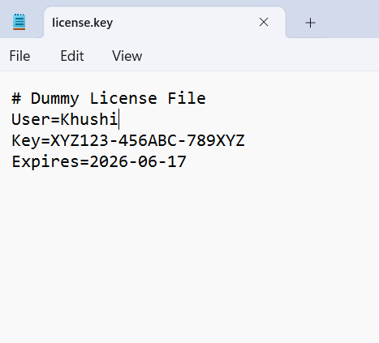

**Step 5:** Go to command prompt (run as administrator)

* First, go to the path where your dummy.msi exist in folder which you created names as Project2 in cmd

Run these commands from Developer Command Prompt (WiX Toolset must be installed):

1st command -> candle DummyProduct.wxs

2nd command -> light DummyProduct.wixobj -o DummyProduct.msi

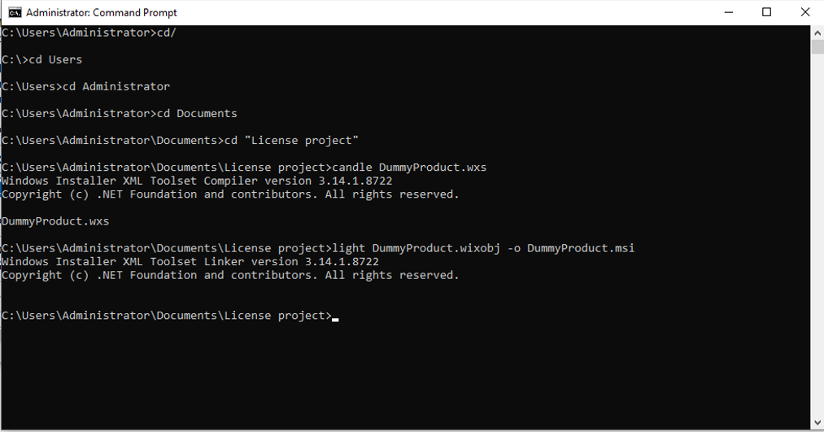

**Step 6:** Open Orca inside that go to file and then open dummy.msi file in orca

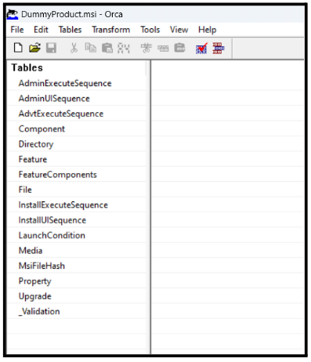

**Step 7:** Click on **File** where left box is there and then one more box will open then **add row**

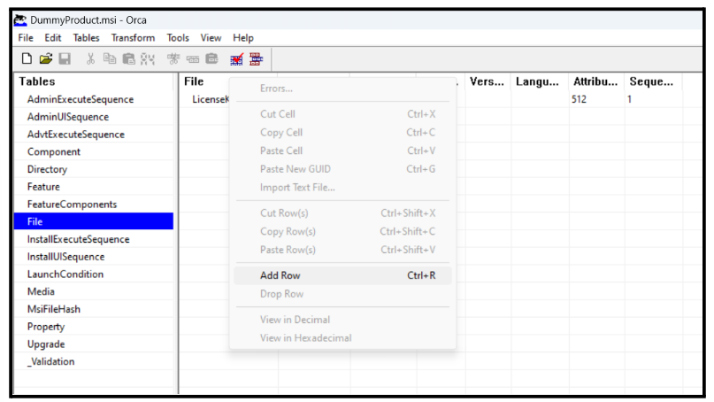

**Step 8:** Put the information according to the .wxs file DummyProduct.wxs

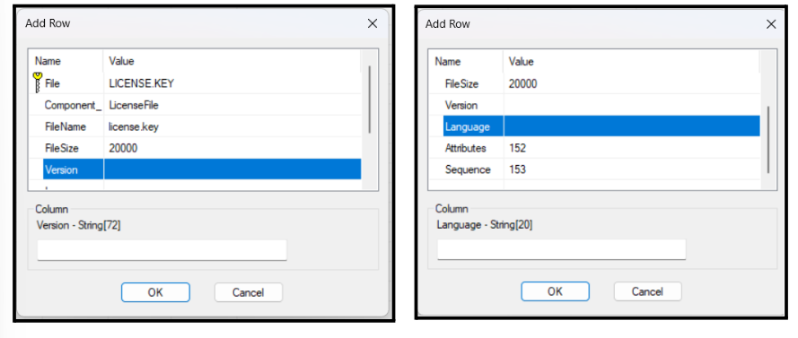

->Then right click on File 1st column and click on add row option and add one row

->Add one row as shown below



**Step 9**: Save the .msi file DummyProduct.msi

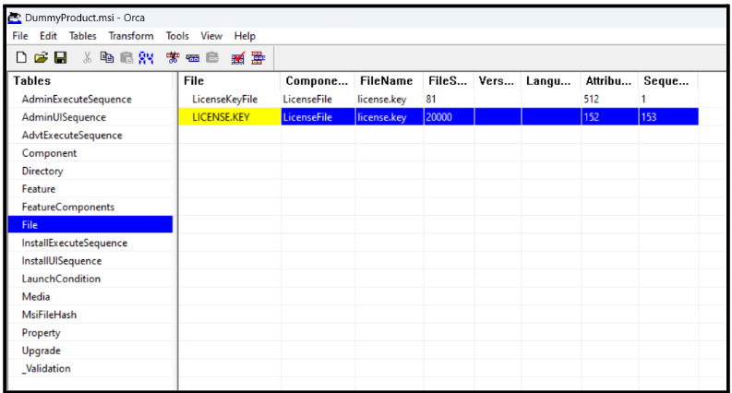

->Save and close

**Step 10:** Now open program file and see the final result

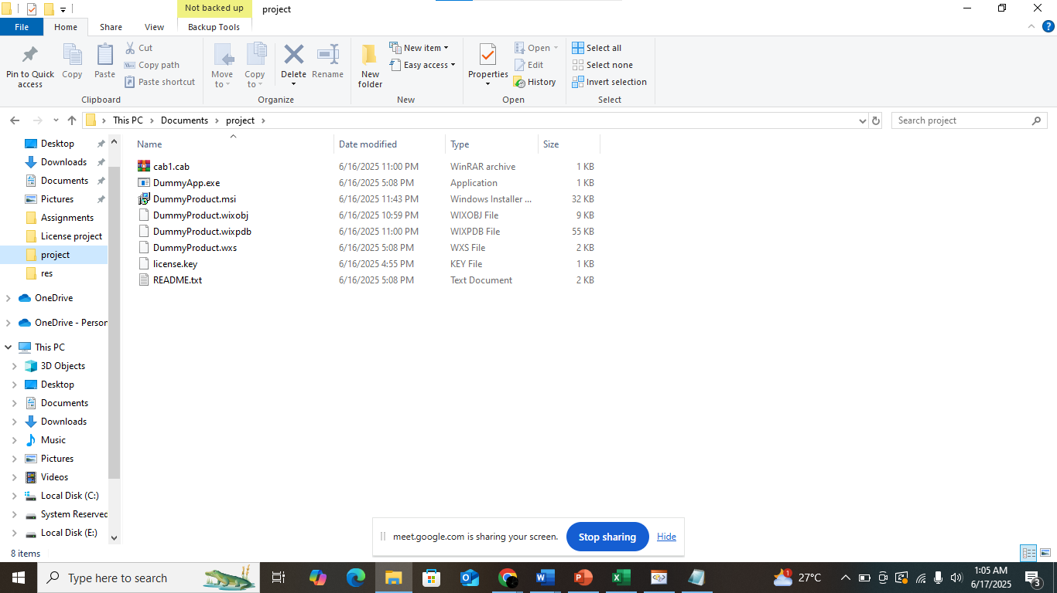

**Analysis Result:**

* **Success:** License file placed correctly
* MSI functions normally with embedded license
* Verified by reinstallation and folder check

**Technologies/Tools Used:**

* Orca Editor
* WiX Toolset (Candle & Light)
* PowerShell/Command Prompt
* Windows 10
* Notepad